Practical - 1
Practical Title: Project Initiation, Requirement Analysis, Sitemap, Wireframe, and GitHub Setup

Problem Definition: Initiate the semester-long StudentHub portal by identifying the problem scope, user roles, key modules, navigation flow, and minimum 10 pages. Create a sitemap, low-fidelity wireframe, project folder structure, README file, and GitHub repository.

What is URL and parts of URL?
Answer: Uniform Resource Locator
Parts of URL is http, www, domain name, path, query string

How does HTML file process in web browser?
Answer: First we can write code in vscode and make .html file. Browser send req to web server.

3. How will page navigation flow managed among all HTML pages?
Answer: The index.html file is the main page of the website. From this page, we can access other pages like about, faq, home, contact, etc. This process is called navigation flow. In html, we can navigate between pages using the a tag with the href attribute.

4. How will GitHub commits be maintained after each practical?
Answer: After completing each practical, I will create a separate GitHub commit with a clear and meaningful commit message, such as "Completed Practical 2". Then, I will push the commit to GitHub. This helps keep a proper record of all changes and makes it easy to track progress or restore previous versions if needed.

Evidence of Work (Screenshots)
Description:
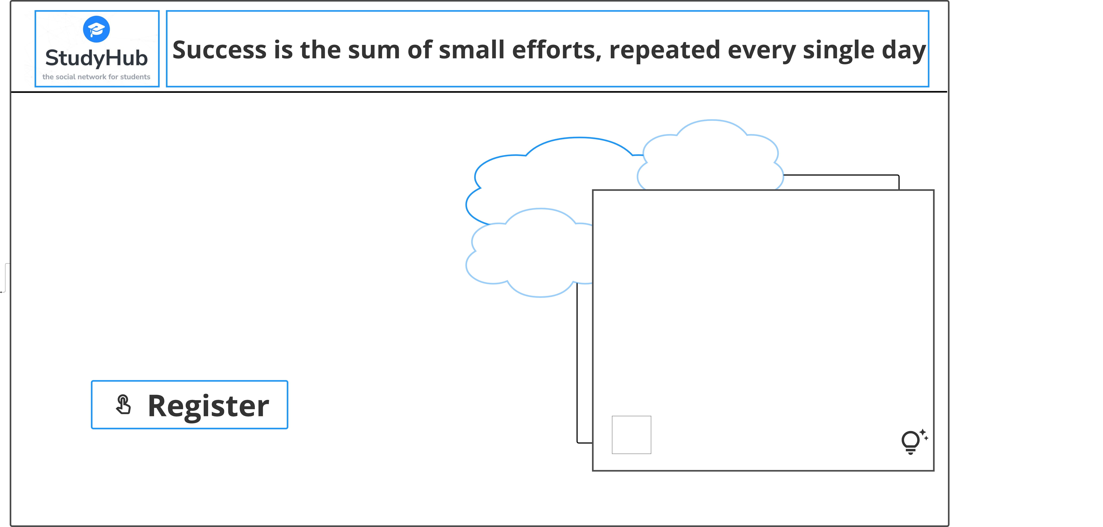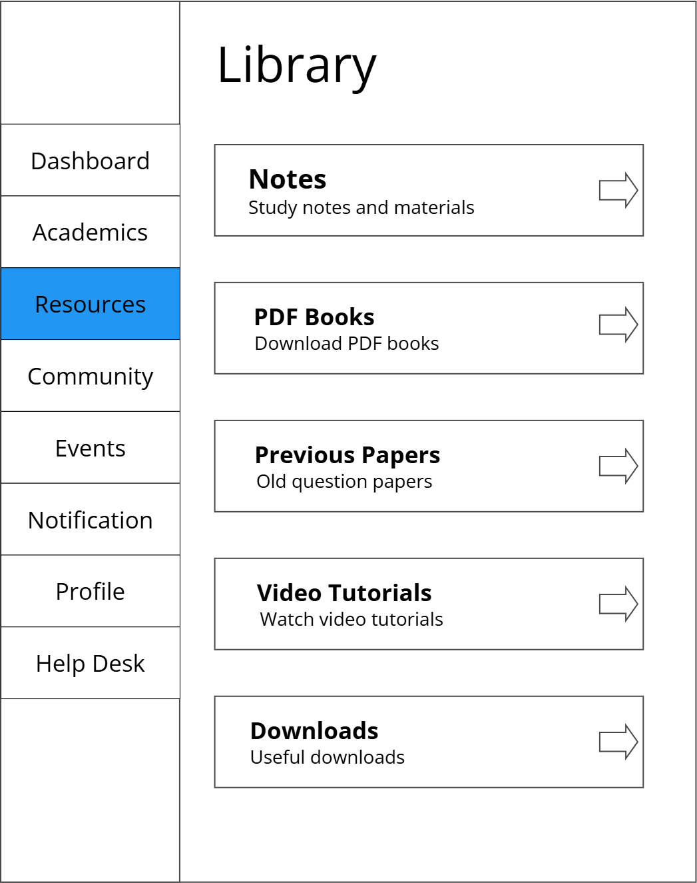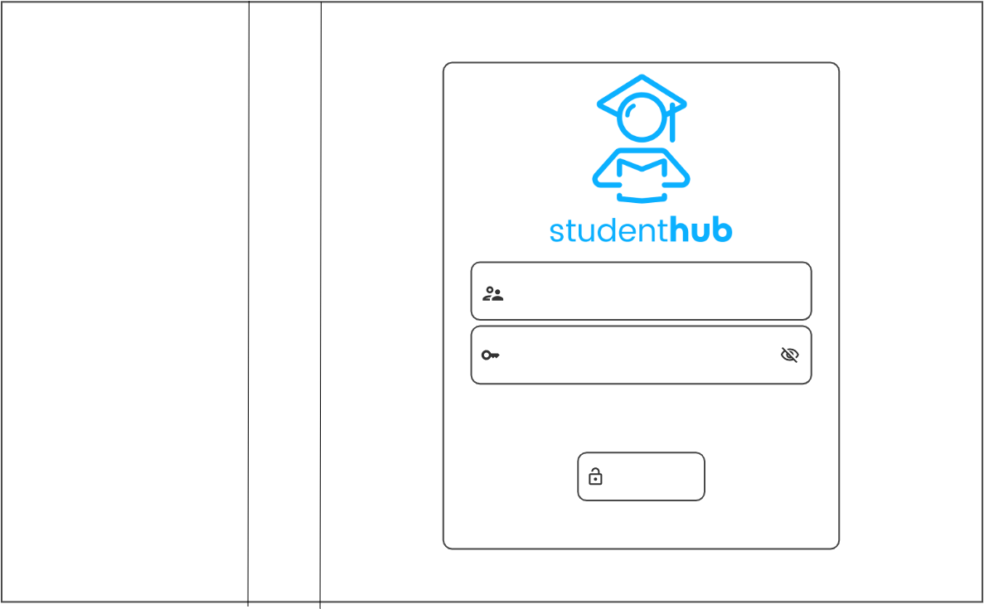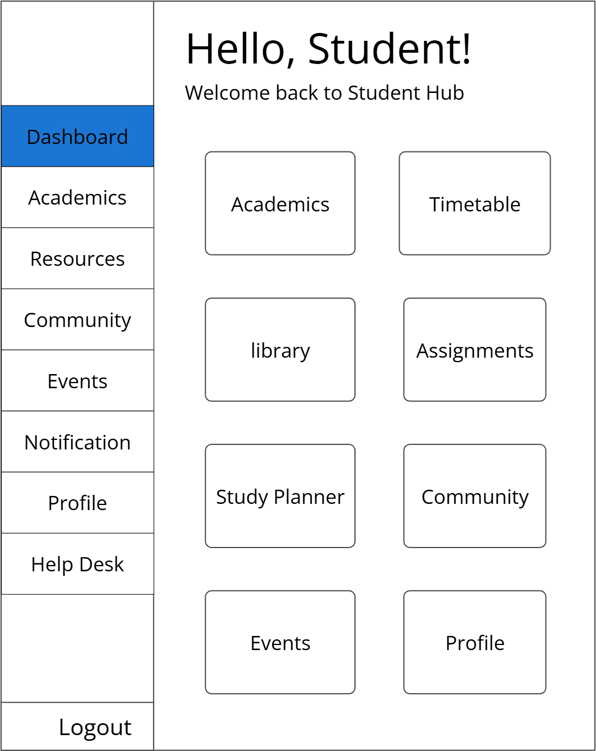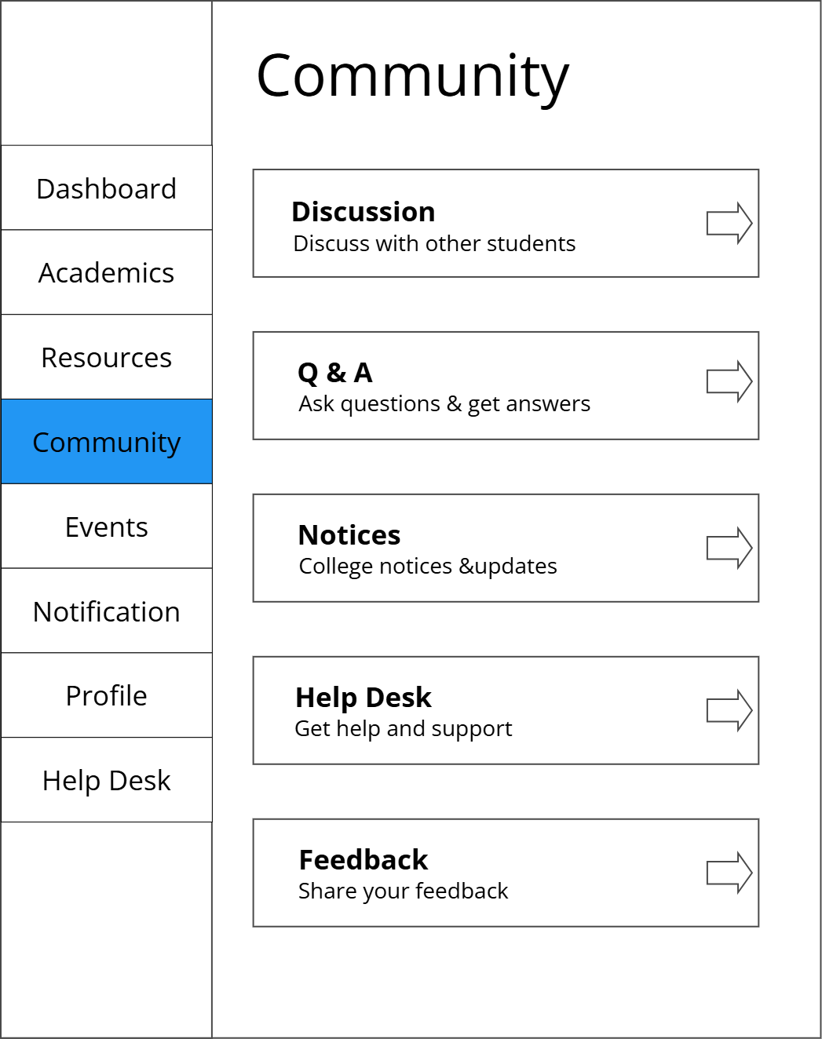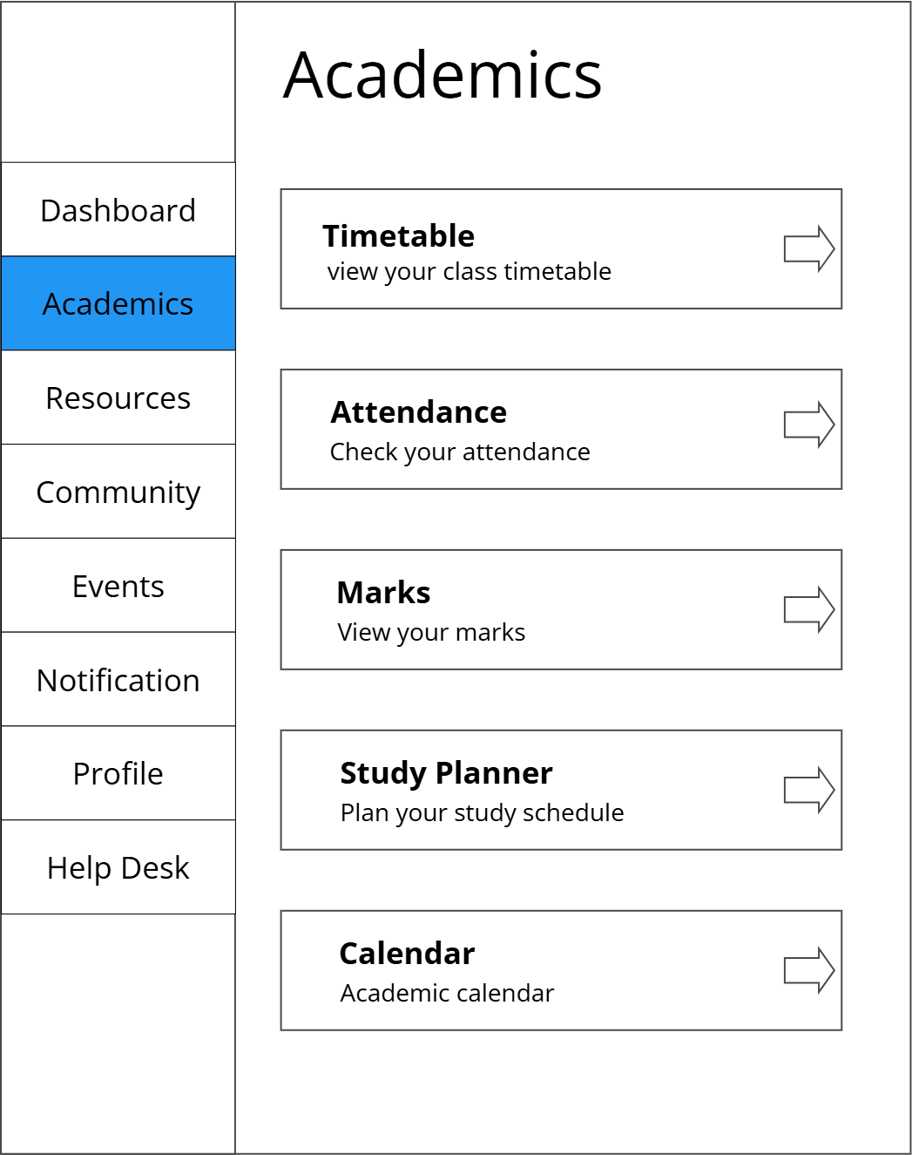

Description:
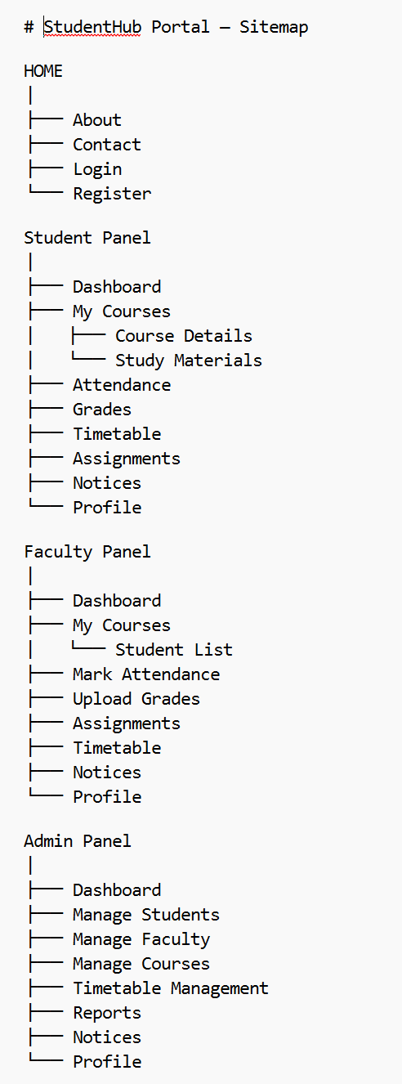

GitHub Repository Link:

https://github.com/adrojatarang8-art/StudentHub.git

Challenges Faced:
Answer: When I first wrote HTML code, I couldn't remember many things. But now, HTML has become easy for me. When I started applying CSS to all the pages, it became complicated because I had to connect it with index.html and all the other pages. I tried 3–4 times in a week, but whenever styling errors occurred, I didn't know how to fix them or set the CSS properly. It was a little difficult for me, but with practice, I started understanding it better.

Learning Outcomes:
- I learned many things about HTML and CSS, so now they are easy for me. However, connecting different pages and applying CSS to all of them was very difficult at first. But now I can implement most of the things correctly, so it has become much easier for me.

Faculty Remarks: (Keep this blank for faculty)

